1. This is most useful and most challenging operator.
2. It can be used in conjunction with other operators such as $set and $unset.
3. It points dynamically to certain elements of an array.   
   Position depends on the update query.
4. $ represents indices of array elements.
5. 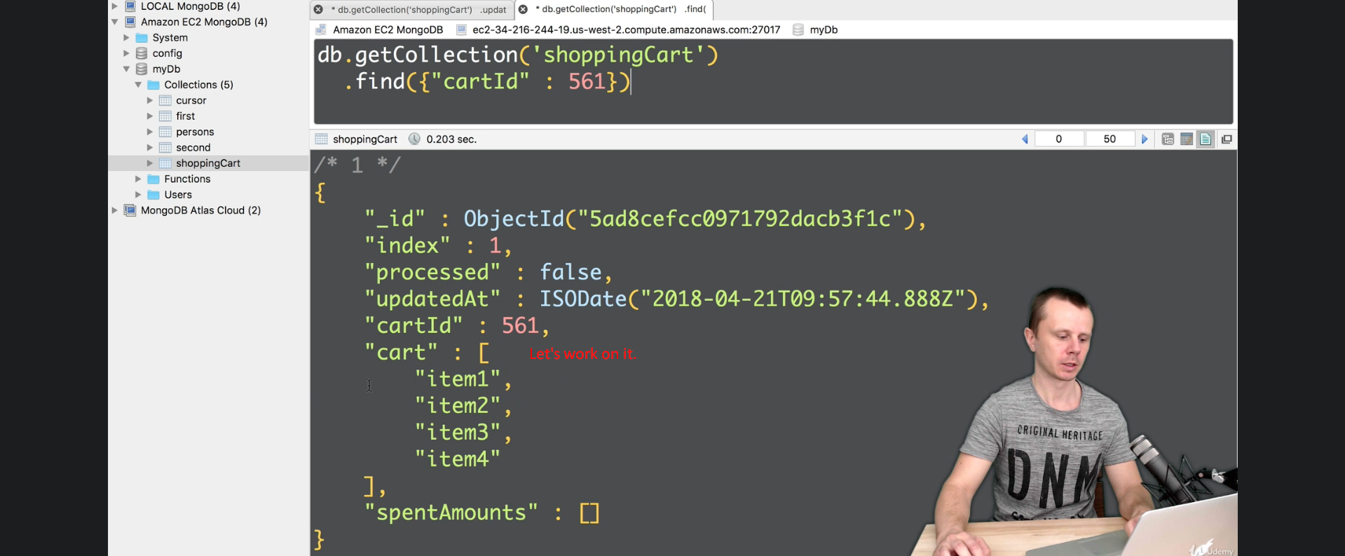
6. 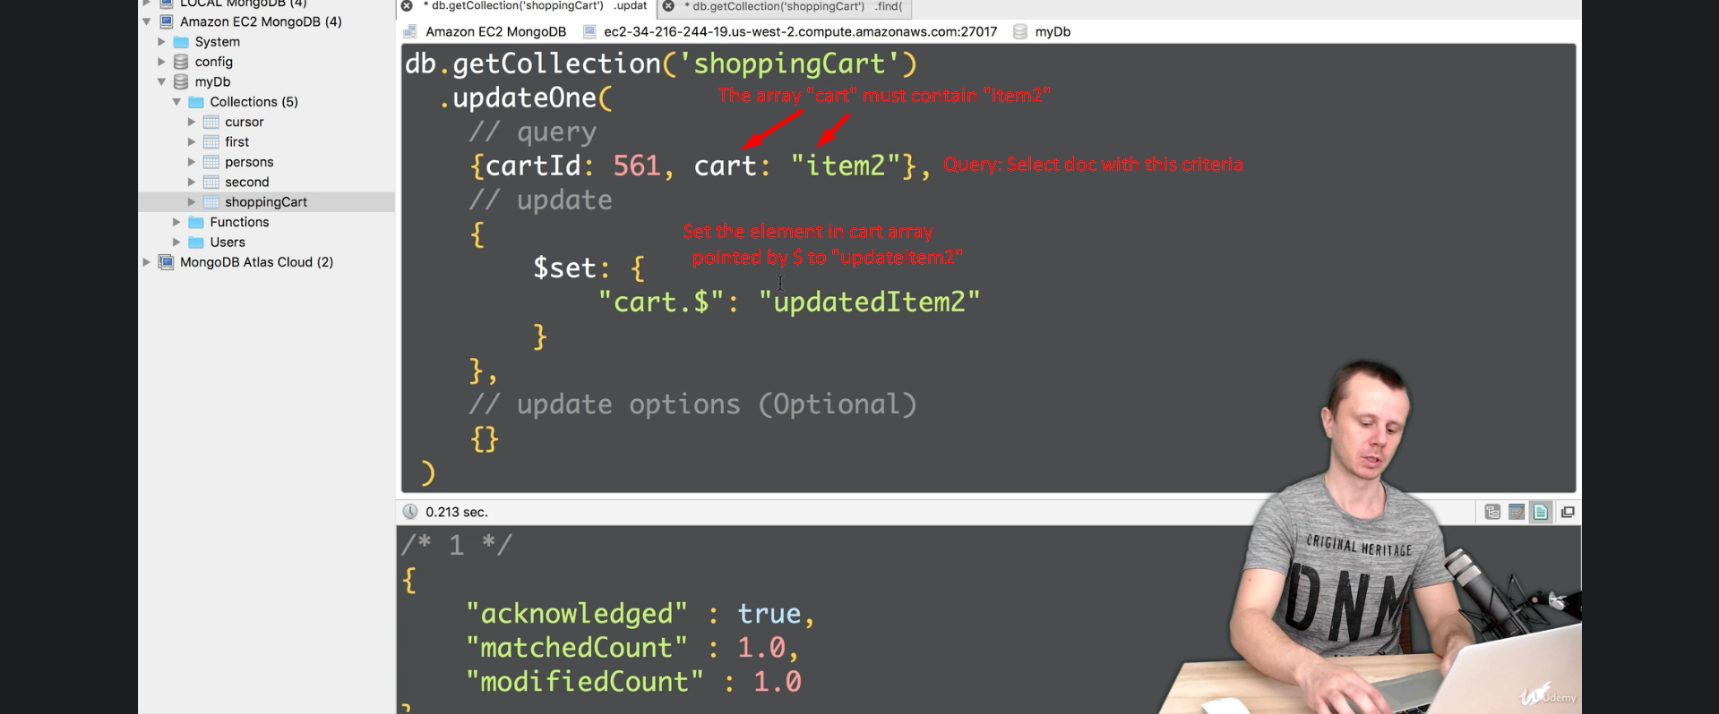
7. 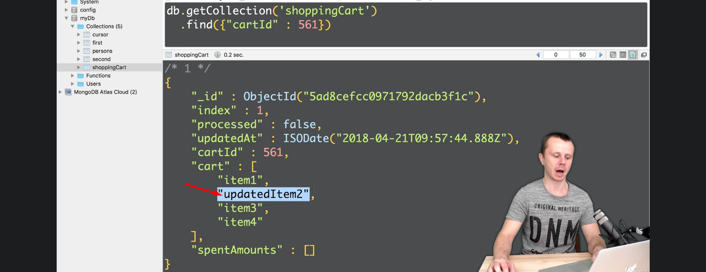
8. 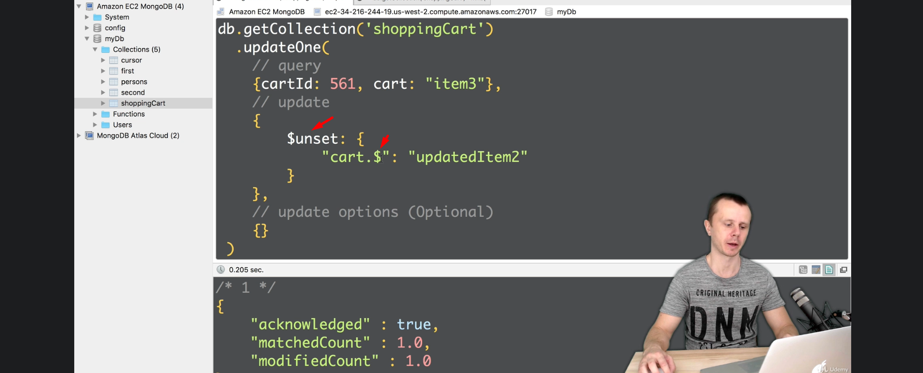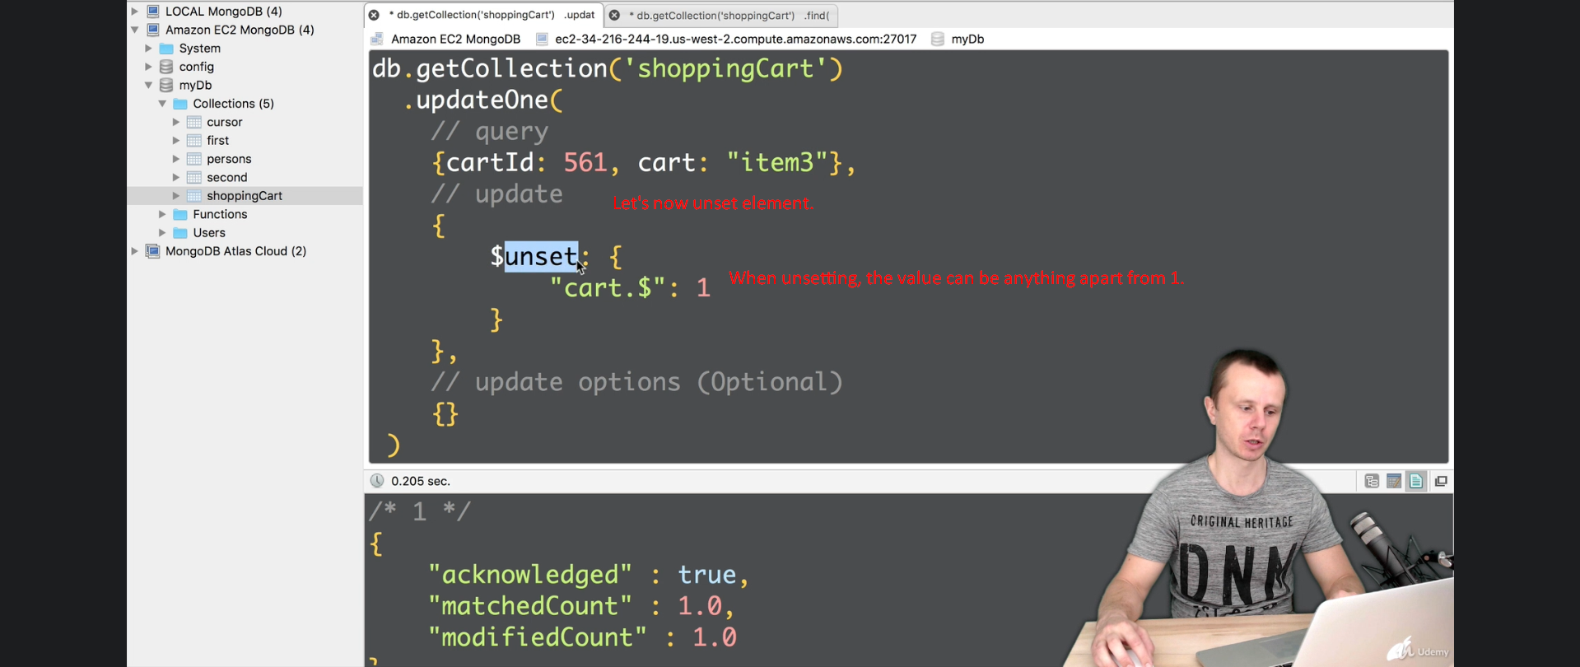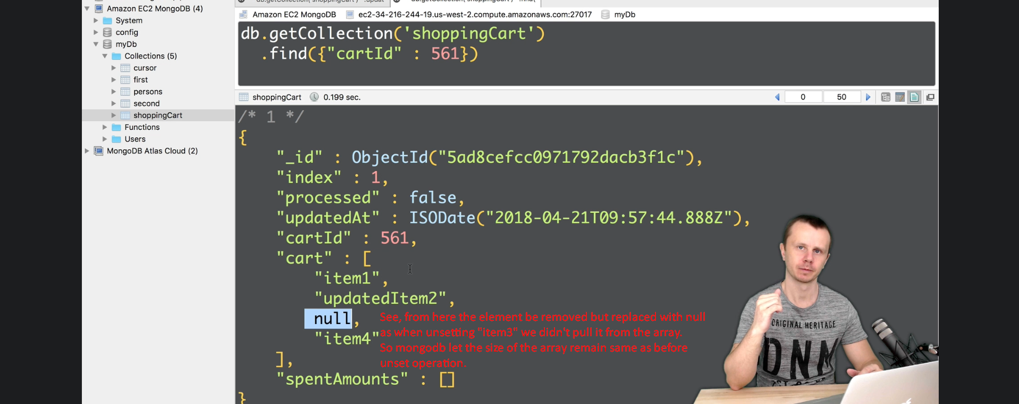
9. 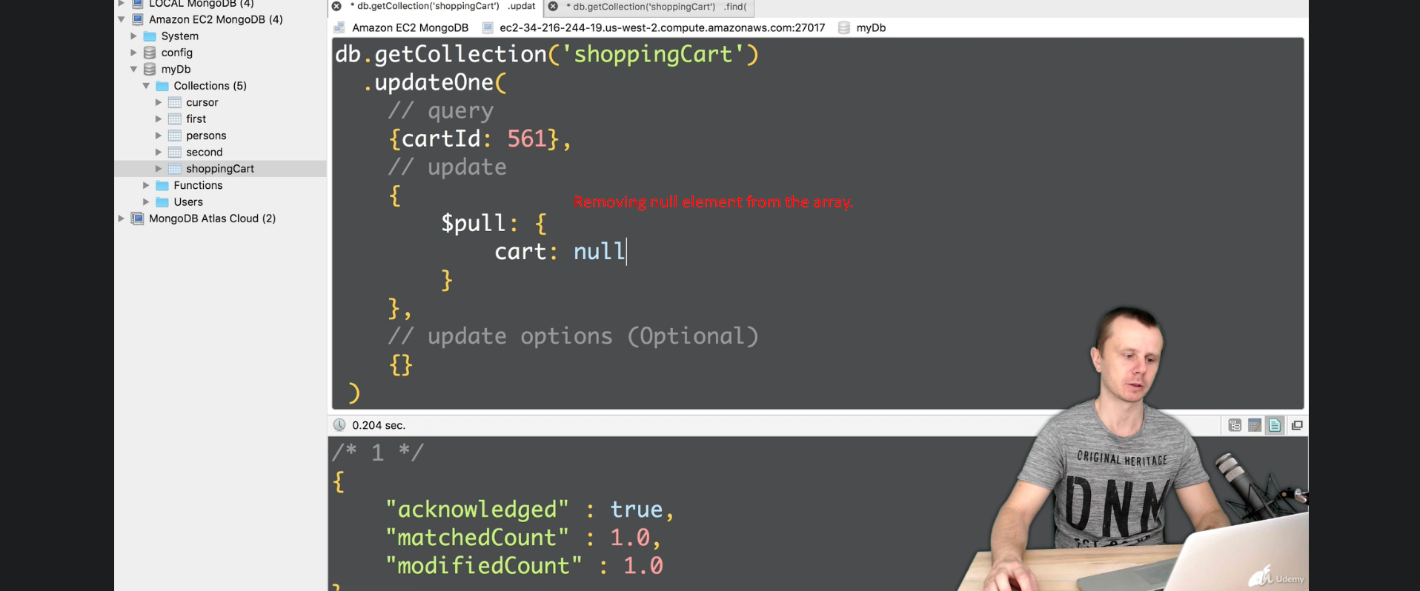
10. 